**CRIME DATA ANALYSIS AND VISUALIZATION**

**ABSTRACT**

Crime data analysis and visualization is a systematic approach for identifying and analyzing patterns and trends in crime. Our system can display regions of crime occurred according to year, month, day of the week, hour and can also visualize crime areas according to crime category. The application allows you to toggle between the different types of crime for selected months of the year whose locations are then plotted alongside on the map.

One important facet of this effort is to design improved methods for data visualization, analysis, and interpretation. In this effort, we demonstrate how data and analytics are used to assess how well criminal justice system objectives are met and how analysis results can be presented using an advanced data visualization tool. With the increasing advent of computerized systems, crime data analysts can help Law Enforcement officers to speed up the process of solving crimes.

The results of this solution could be used to raise people’s awareness regarding the dangerous locations. In addition, having this kind of knowledge would help people to improve their living place choices and can increase the level of crime prevention.

**INTRODUCTION**

**Motivation**

Analyzing complexities in criminal networks is a complex issue. They become even worse when there is involvement of external collaborative networks. Criminal nodes in different criminal sub-groups combine to form a big network. It is difficult to explore criminal activity that is building up among the sub-groups. Data from the initial investigations reveal only partial information. Hence, there is a need to find links between the data for getting adequate information. We have introduced novel prediction and visualization features that can help trace the collaborations of the individual criminal nodes with other nodes and detect the patterns of hidden criminal activities in the sub-clusters. The RStudio tool can support crime analysts in analyzing the intra-network criminal activities.

**Purpose of this document**

**In this document,** there is overall description of the Crime Data Analysis and Visualization project. It includes what we did. There is also description of the modelling of the project and all the requirements and future enhancements and the technologies we have used for this project. The purpose of this document is to define requirements of Crime Data Analysis and Visualization and the use case model together capture a complete set of requirements on the system.

**Intended Audience**

The intended audience related to our project are Law Enforcement officers, Police officers and Criminals. It is mainly useful for Law Enforcement officers to speed up the process of solving crimes and for the normal citizens in the form of awareness regarding the dangerous locations so that they may improve their living place choices.

**Scope of the project**

Crime data Analysis and Visualization has a great role in improving the crime prevention in local areas and people get aware of the crime prone areas. The future enhancements that can be projected for the project are: More detailed crime data, better the designed and friendly User Interface, etc.

**MODULES:**

In this application we are having 3 modules

1. Core Analysis
2. Neighborhood Analysis
3. Map

## 

## MODULE DESCRIPTION:

**Core Analysis:**

In this module, the user will be provided with a list of time periods such as Year, Month, Day of Week and Hour. User must select one of them which he/she desires to analyze through a Histogram. After selecting the time period, relevant histograms will be displayed based on the offense category and reported date range.

**Neighborhood Analysis:**

In this module, the user must select the maximum results of neighboring areas so that the map will be displayed based upon those number.

After updating, the user can see the graph of neighboring areas based upon their crime rate.

**Map:**

In this module, the user can select the maximum number of results by which the map can be visualized. After updating, the user can see the map in which the crime prone areas are marked as red. If we zoom the map, we can observe the red dots that represent the crime occurred areas.

This visualized map depends on the selection of maximum results the user selects in map and neighborhood analysis, offense categories and the reported date range.

**OUTPUT:**

**CORE ANALYSIS:**

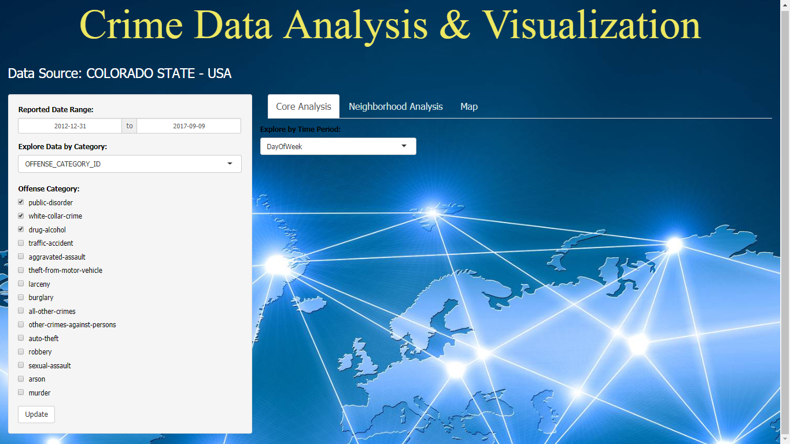

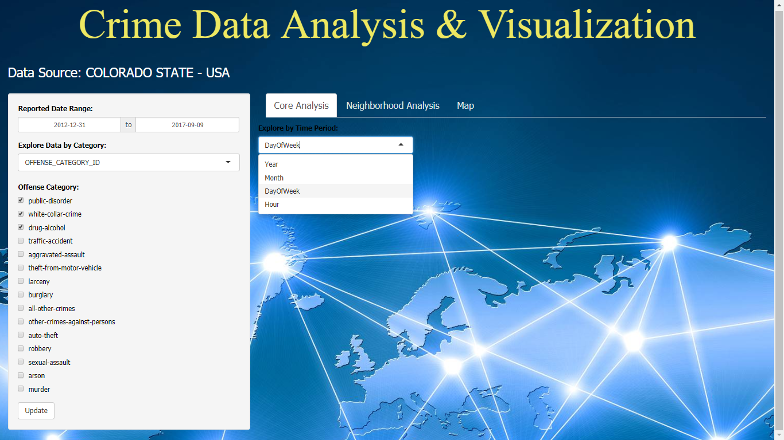

**Year-wise Analysis:**

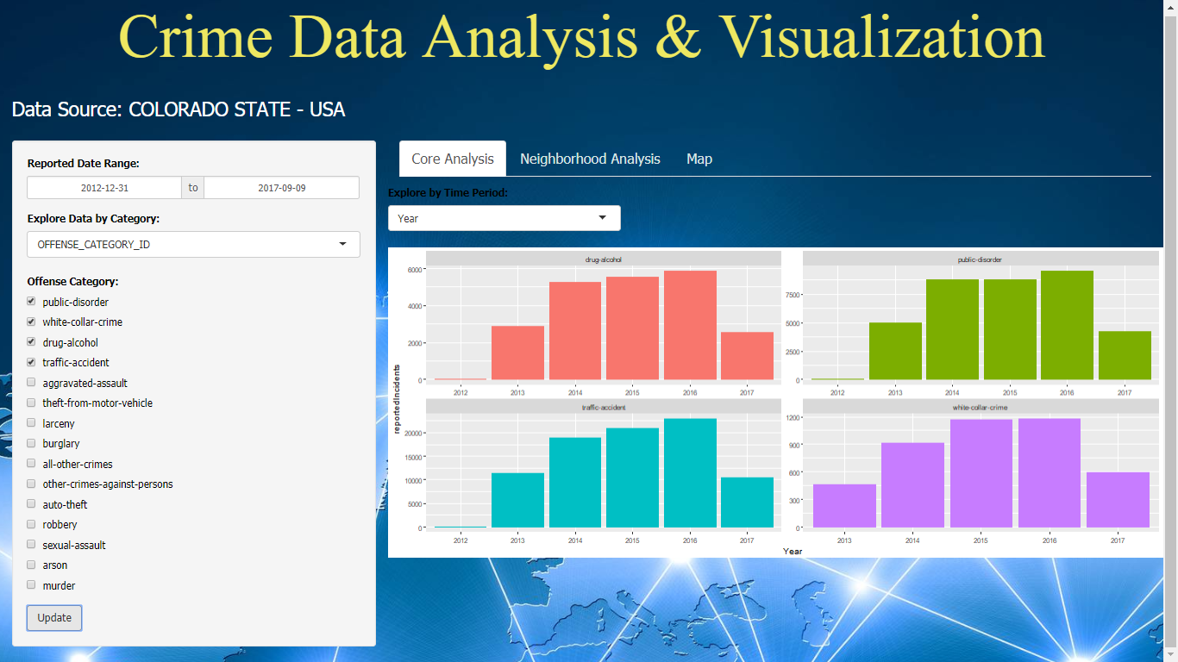

**Month-wise Analysis:**

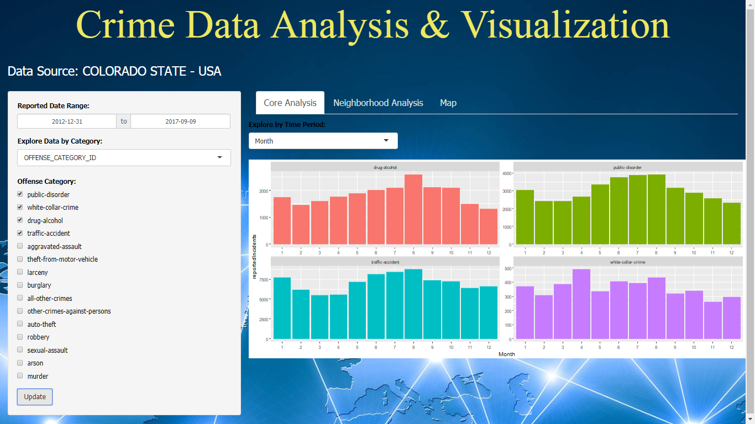

**Day of the week - wise Analysis:**

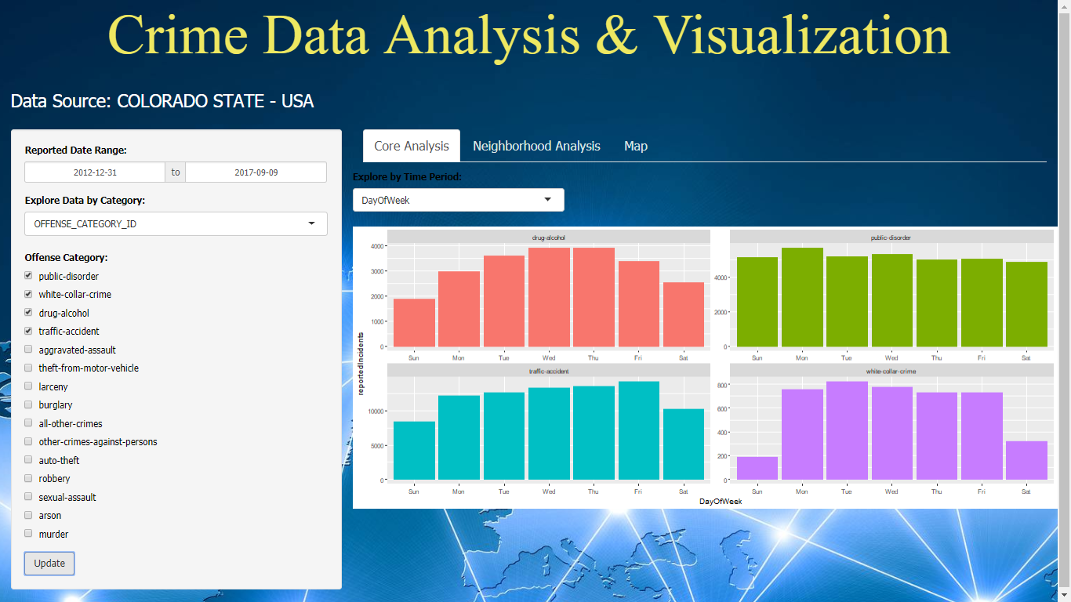

**Hour-wise Analysis:**

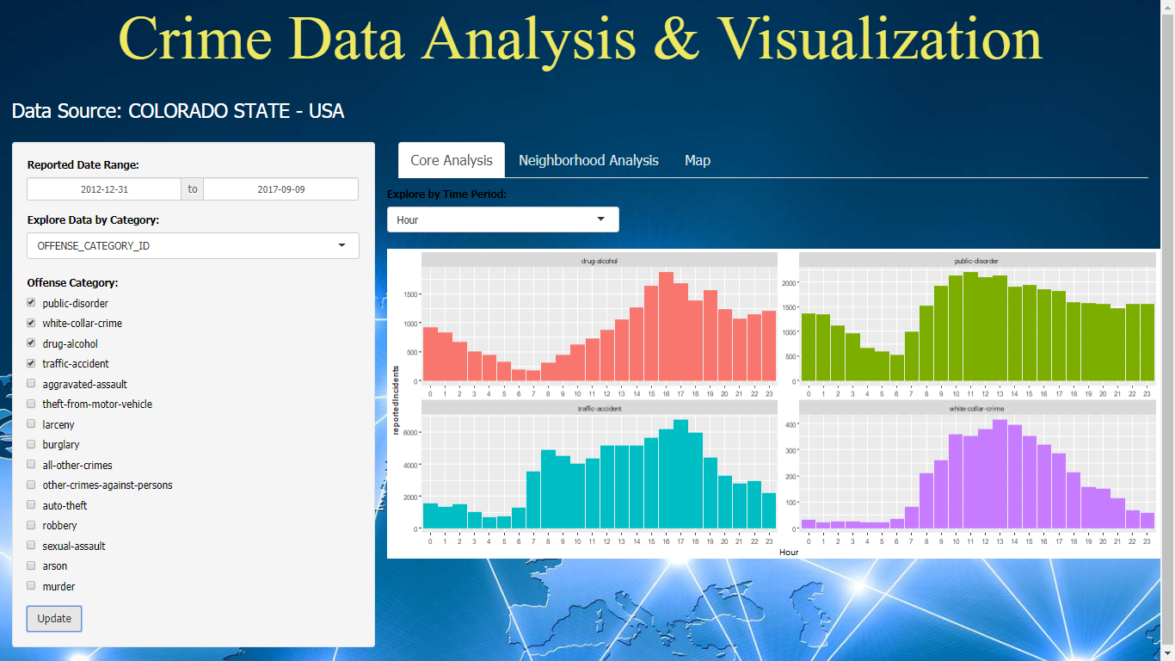

**NEIGHBORHOOD ANALYSIS:**

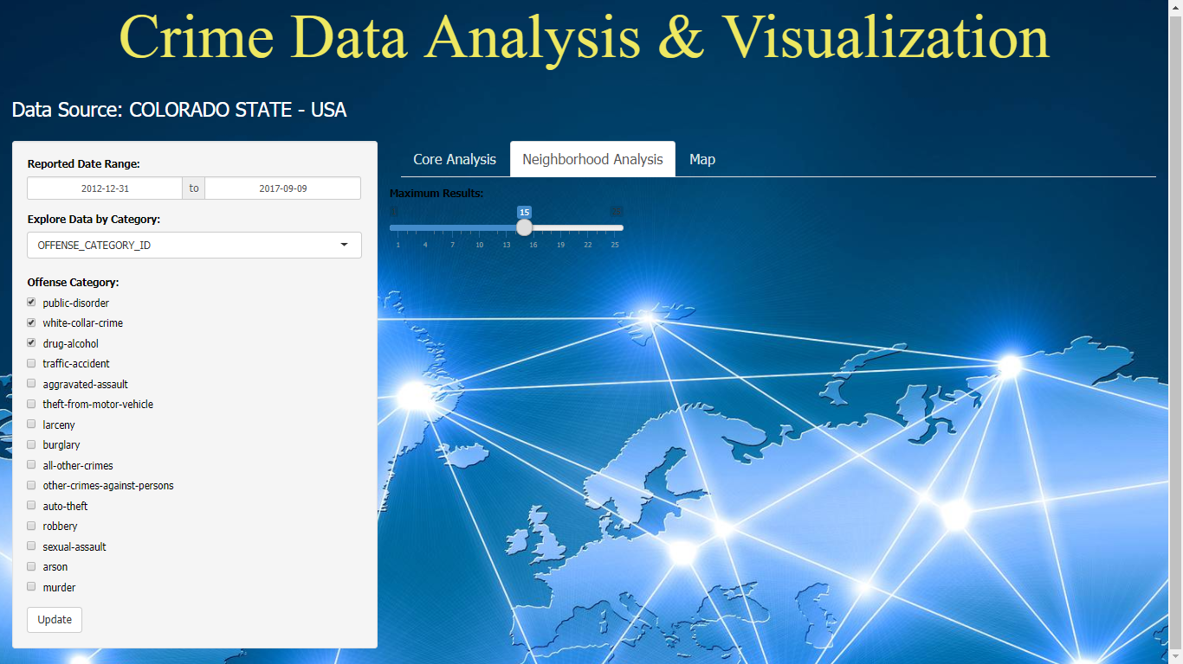

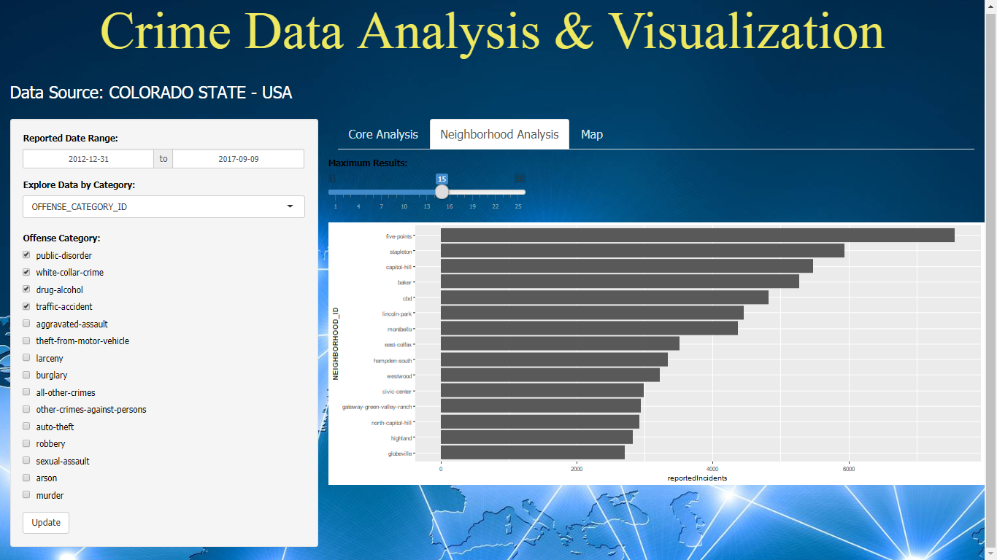

**MAP SCREEN:**

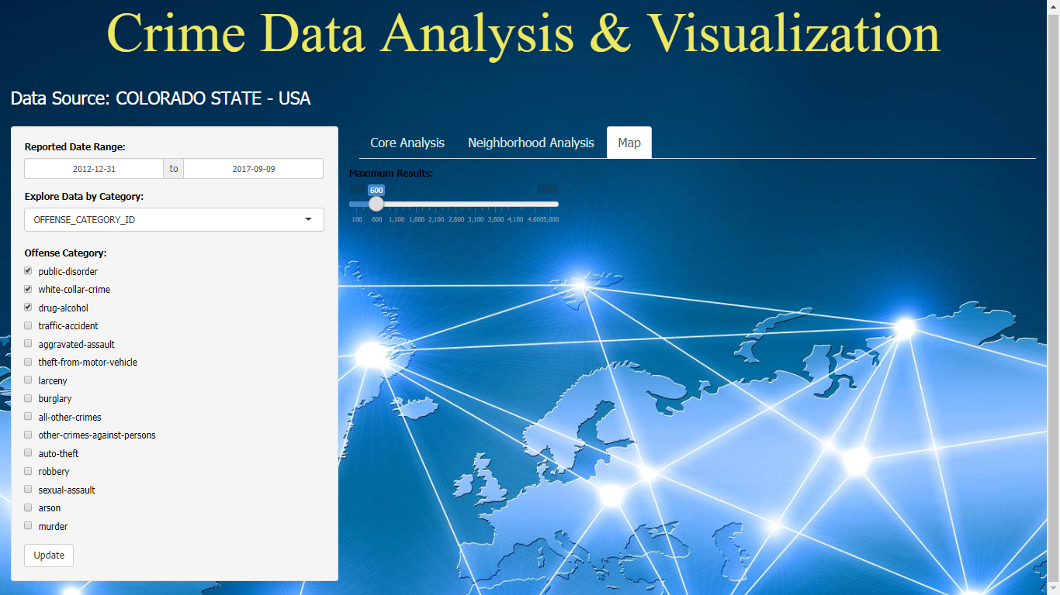

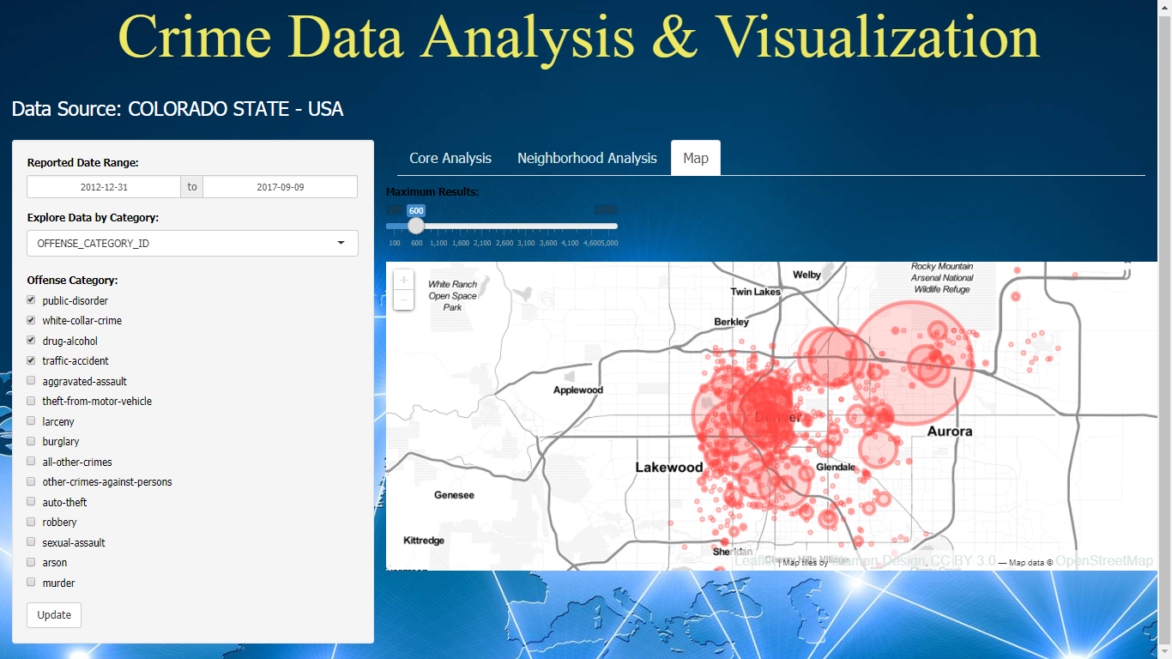

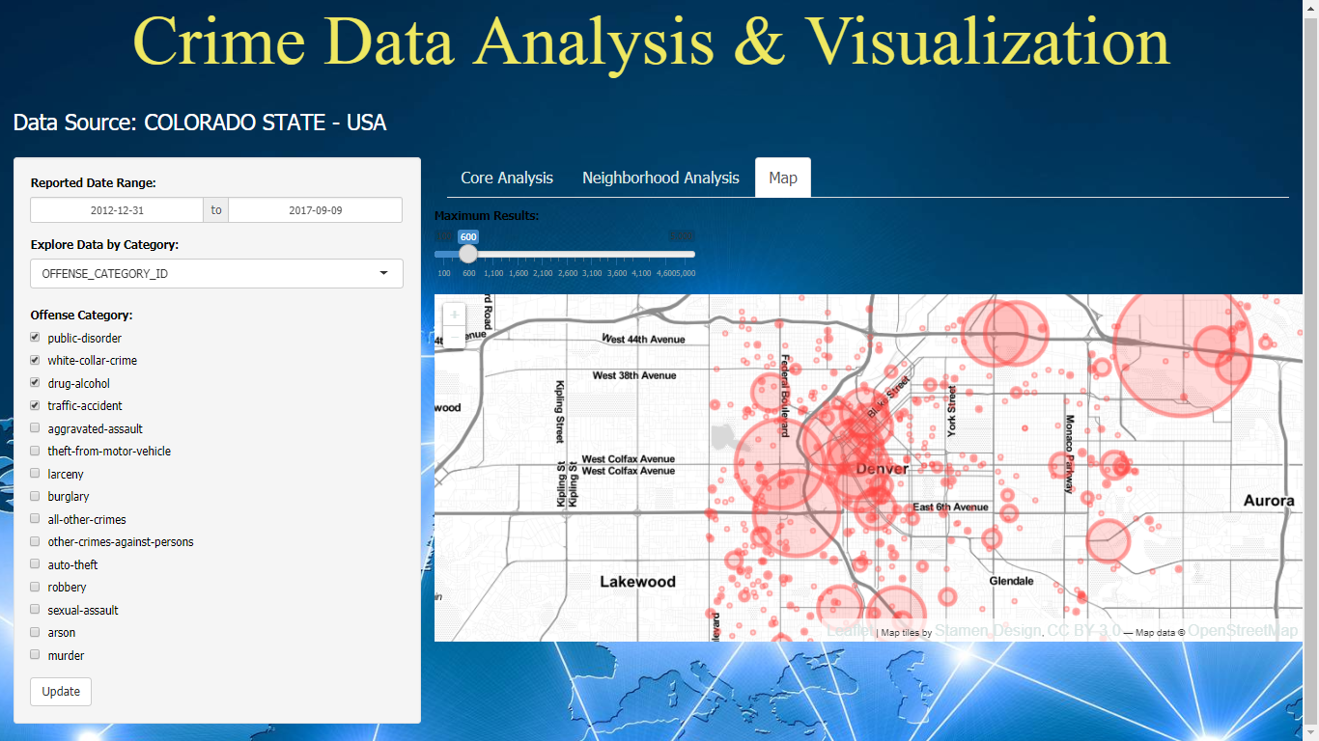

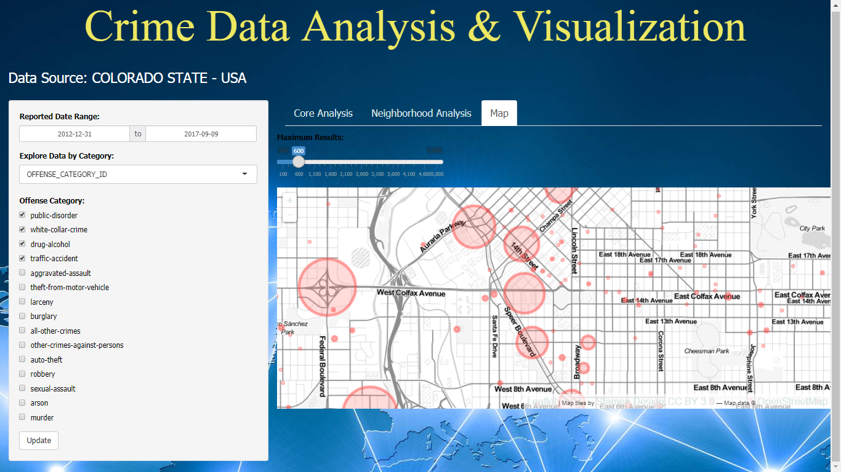

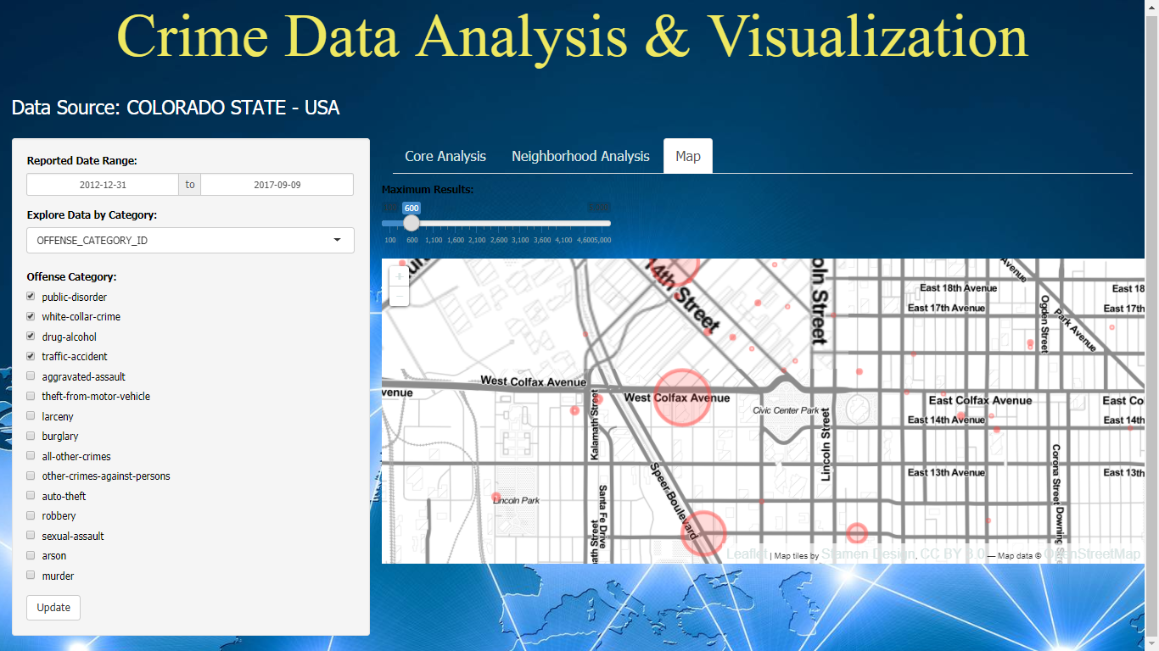

**CONCLUSION**

**We generated many graphs and found interesting statistics that showed the baseline to understand crime dataset.** The crime analysts usually intend to perform their analysis by visualization of the criminal networks. There are several reasons behind the intentions of these crime analysts. Some of these reasons include the simple, easy to use, and understandable interface provided by the visualization tools since interactivity plays a brilliant role in making visualization more understandable. Due to the above reasons, the crime analysts require advanced tools to perform their investigations.

**Finally, we provided an analysis study by combining our findings of crimes dataset with its demographic information. We aimed to further understand our models’ findings and to capture the factors that might affect the safety of neighborhoods.**

1. **FUTURE ENHANCEMENT**

Crime data Analysis and Visualization has a great role in improving the crime prevention in local areas and people get aware of the crime prone areas. The future enhancements that can be projected for the project are:

* A Mobile Application can be developed.
* Better designed and friendly User Interface.
* Notifying the user when he/she turns on the mobile location.
* Recommending and cautioning the friends.
* More detailed crime data.
* Messages to intimate the user when any crime occurs in his/her living area.